ITC Promotion Admin Guide
The Admin and the API share one promotion list of at most 5 product SKUs.
1. Enable the promotion service
Go to Stores > Configuration > ITC > Promotion.
Leave Scope at Default Config.
Set Enable Promotion Service to Yes, then save.
When this is No, the public API returns an empty list, and both Admin saves and API updates are rejected. The switch applies to the whole installation.
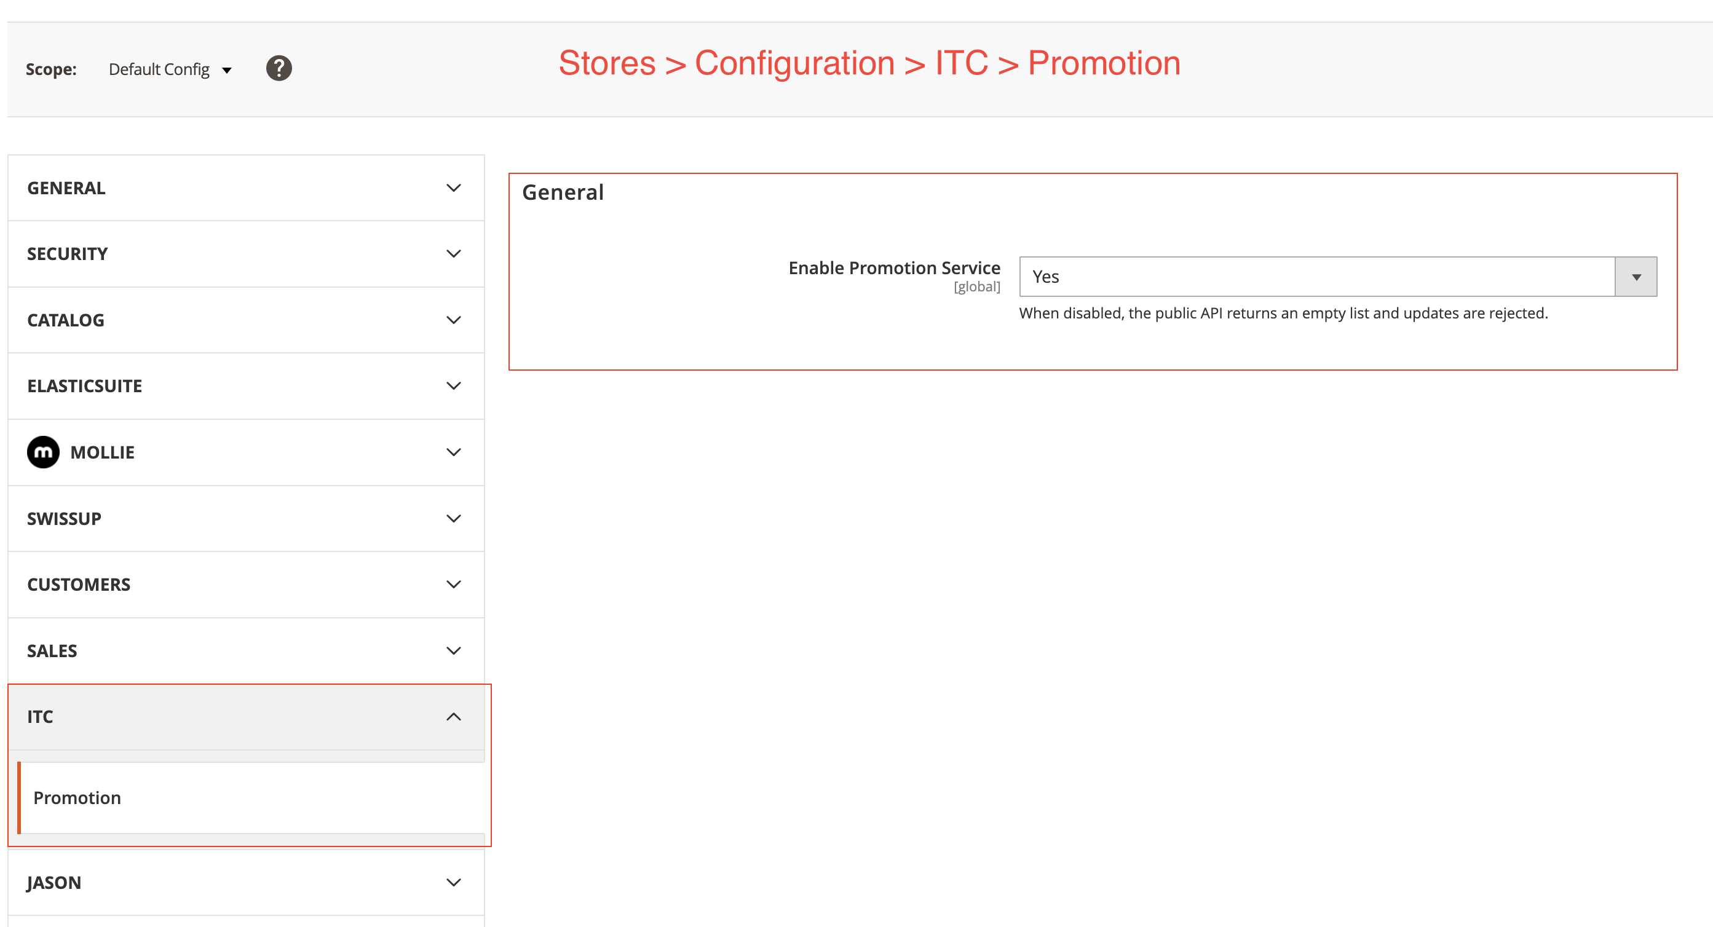
Figure 1. Enable Promotion Service
2. Open the promotion product list
Go to Marketing > ITC > Promotion Products.
The grid has no store switcher. The installation keeps one shared list. Product name, price, special price, and status are the default-scope values. Stock status is the default stock index. Click a product name to open the catalog product edit page.
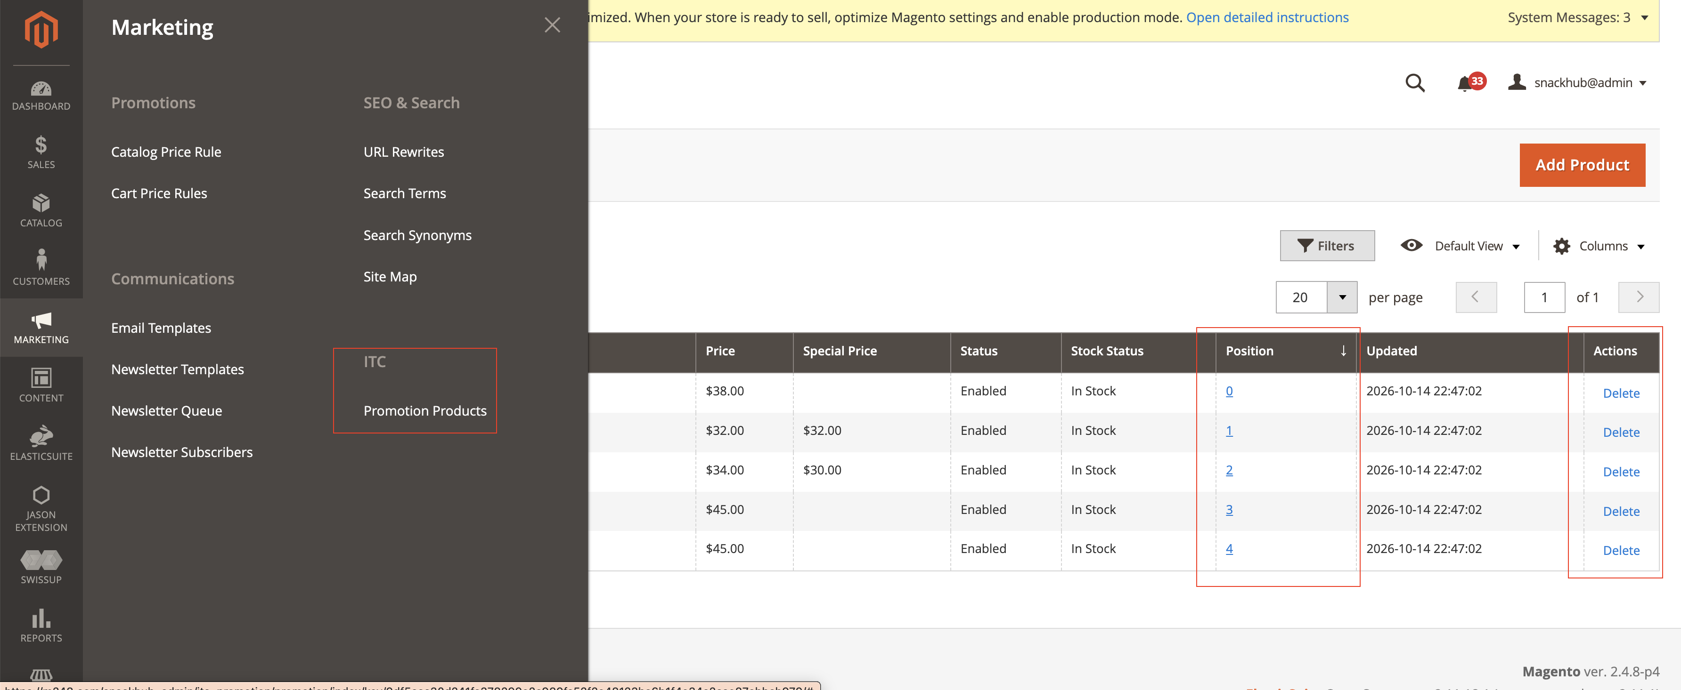
Figure 2. Marketing > ITC > Promotion Products
3. Add products
Click Add Product at the top right.
SKU: enter up to 5 SKUs, separated by commas. Example: 24-MB01, 24-MB04, 24-MB03.
Position: optional. Use the same order as the SKUs, also separated by commas, for example 0, 1, 2. Leave it empty to append the SKUs.
Click Save. One save writes the whole batch.
SKUs already stored plus the new ones cannot exceed 5. Every SKU must already exist in the catalog.
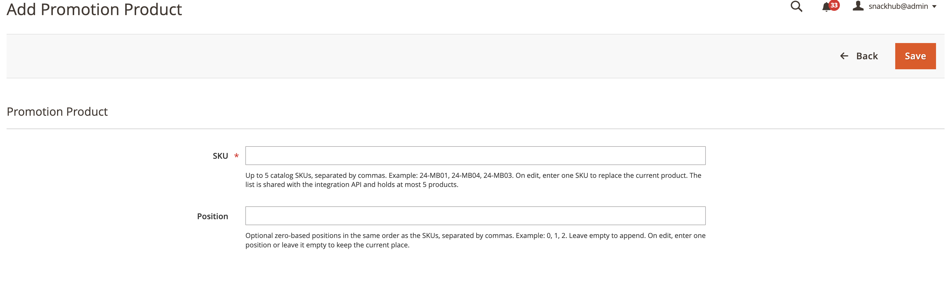
Figure 3. Add a promotion product
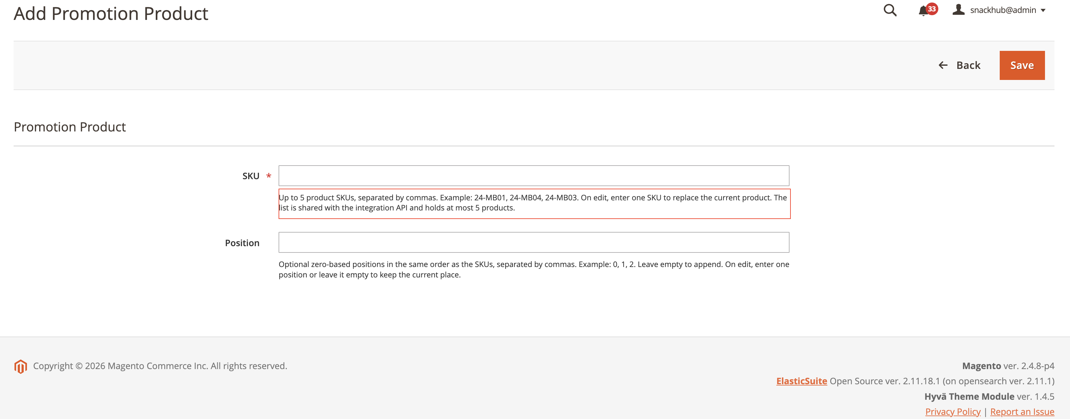
Figure 4. SKU notice: up to 5 product SKUs, separated by commas
4. Adding another SKU when the list already has 5
If the list already has 5 SKUs, saving one more fails. The page shows: A promotion list cannot contain more than 5 SKUs. That save does not write anything. Delete an existing row before adding a new product.
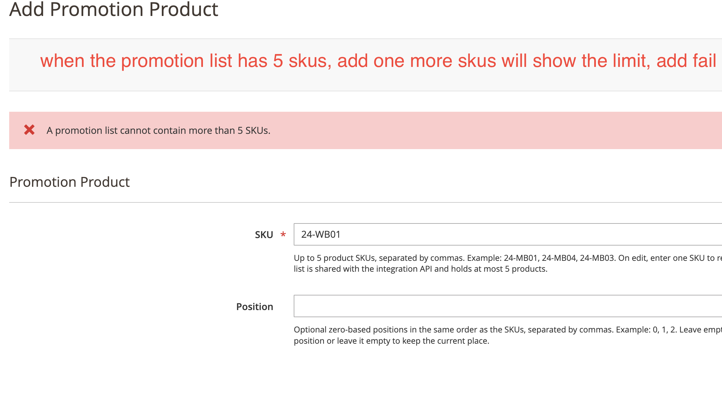
Figure 5. Save fails when the list would exceed 5 SKUs
5. Change the sort order
Edit Position on the grid. You do not open the edit form.
Click the blue number.
Type a whole number from 0 through 65535.
Click Update, or press Enter.
Only that row keeps the number you entered. The other rows are not renumbered. The list is sorted by those numbers. The Actions column only has Delete.
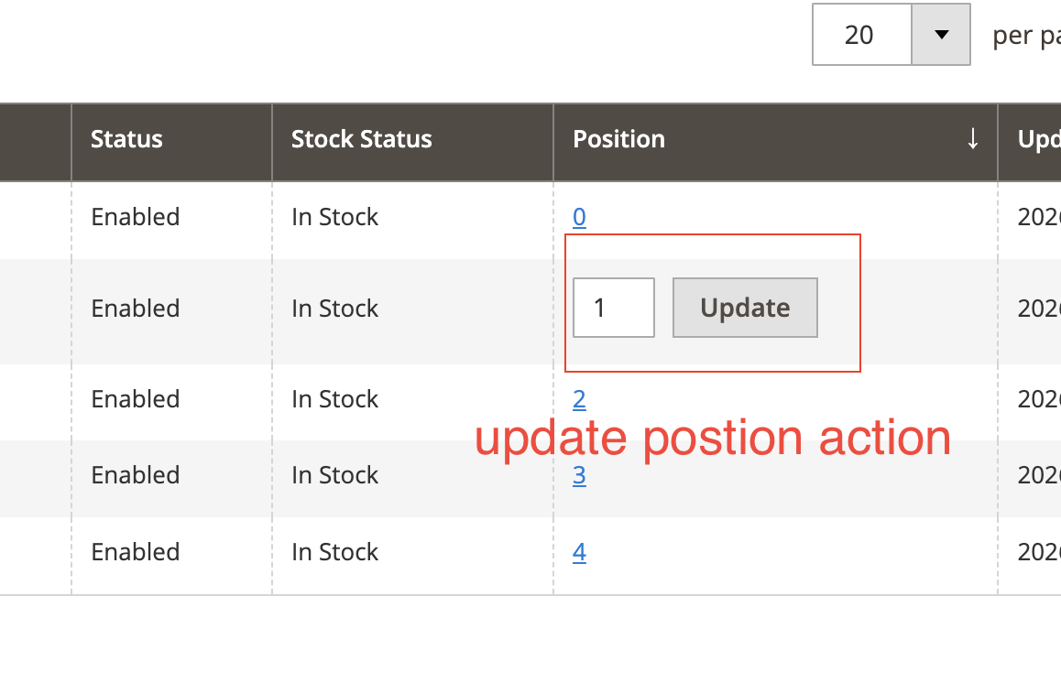
Figure 6. Click the number, type a new position, and click Update
6. Delete one row
Click Delete in that row's Actions column and confirm. The SKU is removed from the promotion list. The catalog product is not deleted.
7. Allow the API to use an access token
Before replacing the list in Postman, turn on Bearer tokens.
Go to Stores > Configuration > Services > OAuth.
Set Allow OAuth Access Tokens to be used as standalone Bearer tokens to Yes, then save.
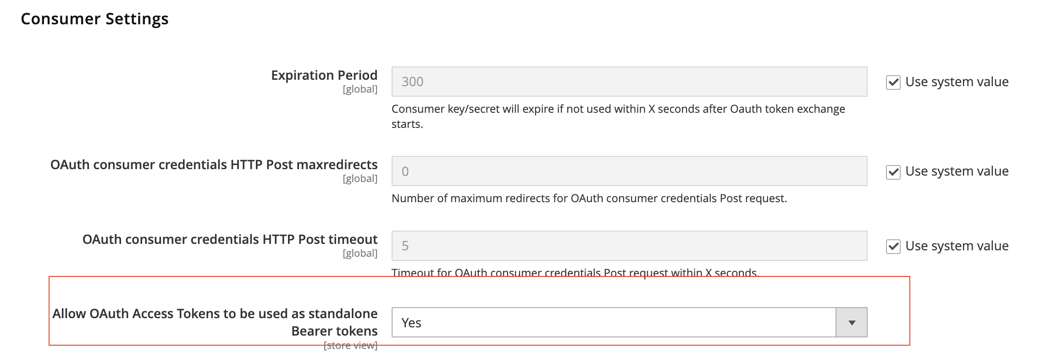
Figure 7. Allow an OAuth access token to be used as a Bearer token
8. Grant the integration permission
Go to System > Extensions > Integrations and create or edit an integration.
Open the API tab and set Resource Access to Custom.
Select ITC Promotion. Replacing the list requires Replace Promotion List via API.
Save, click Activate, then click Allow.
Copy the Access Token from the popup. The Admin does not show it again after you close the window. If you did not copy it, click Reauthorize on that integration. That creates a new token.
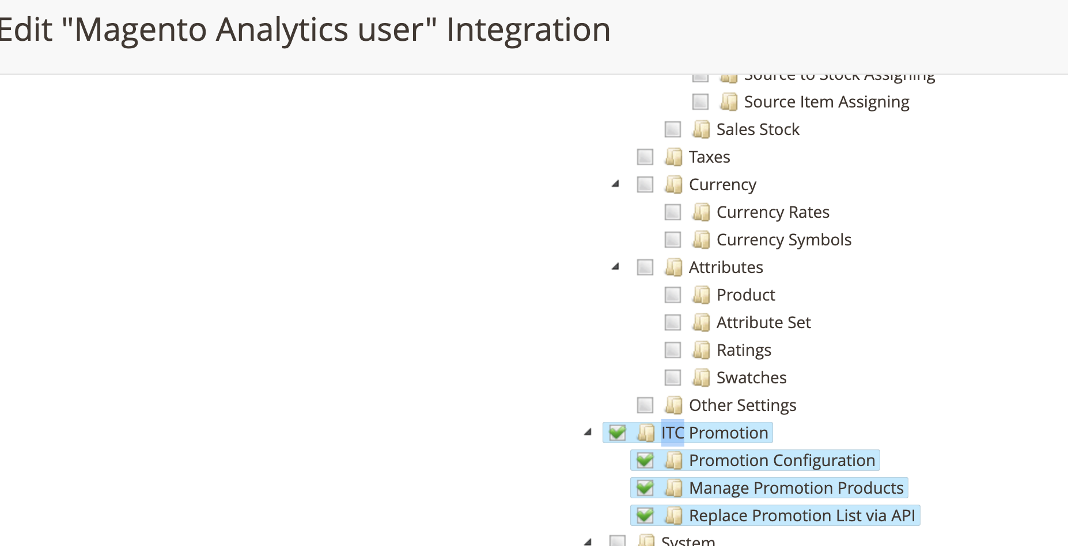
Figure 8. ITC Promotion resources on the integration
9. Read the list in Postman
GET does not need a token. If Postman reports that it cannot verify the certificate, turn off SSL certificate verification in Postman Settings for this local site.
Method: GET
URL: https://m248.com/rest/V1/promotions/products
Authorization: No Auth
Success is HTTP 200. The body is items: the salable promotion products, at most 5. A stored SKU is omitted when the product is disabled, not salable, or not assigned to the current website.
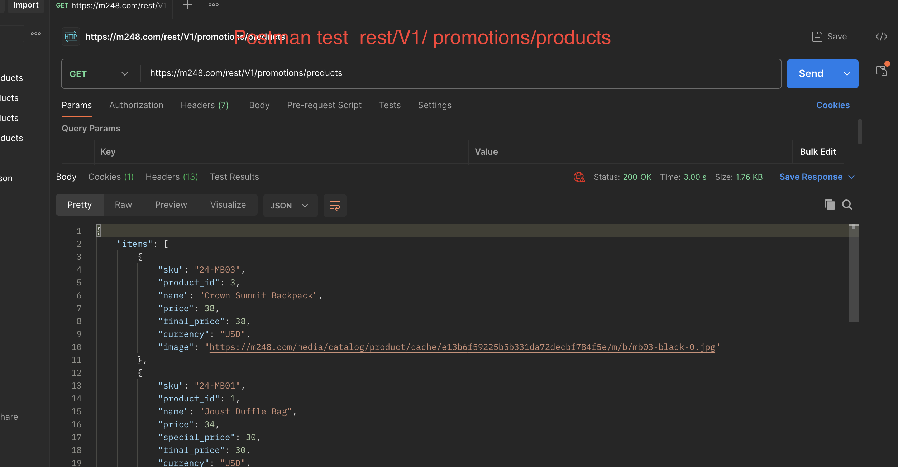
Figure 9. Postman GET for the promotion products
10. Replace the whole list in Postman
PUT replaces every promotion product currently stored. It does not append.
Method: PUT
URL: https://m248.com/rest/V1/promotions/products
Authorization: Bearer Token. Paste the Access Token copied in step 8.
Body: raw JSON, for example {"skus":["24-MB01","24-MB04"]}
Success is HTTP 200. The response contains the stored skus and count. To clear the list, send {"skus":[]}.
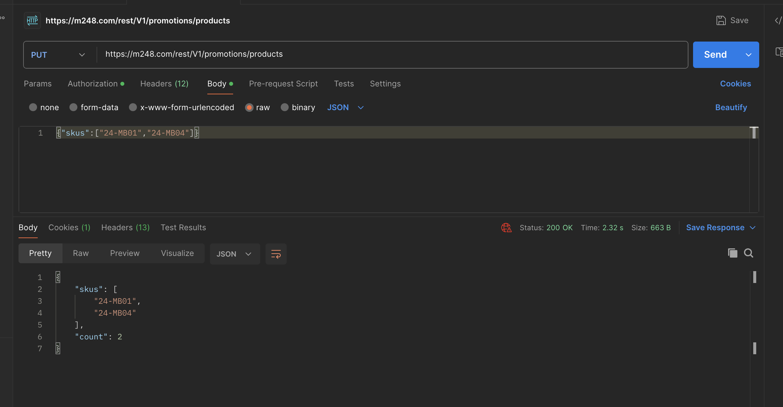
Figure 10. Postman PUT replaces the promotion list
11. Check the Admin after the PUT
Refresh Marketing > ITC > Promotion Products. The grid matches the SKUs sent in the PUT, in the same order.
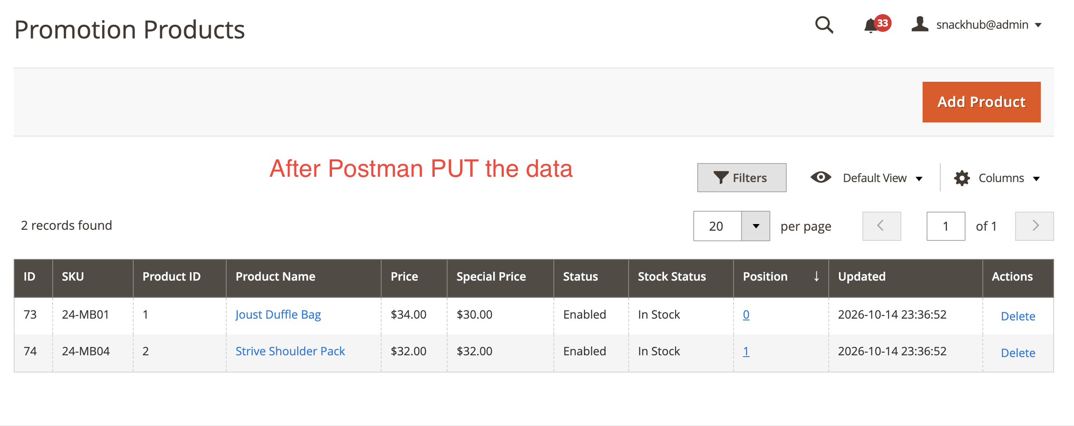
Figure 11. Admin list after a successful PUT

